Project and Developer Details

## Project Name: **Sporty Shoes**

Developer Name: Amal Aldawas

Project Details:

## Steps to use:

1. Open in IDE with Tomcat and SQL
2. Create new database called " sportyshoes"
3. Load in tables/data with information from db with setUpDB.sql file
4. Right Click Project Name and Run on Serve

## Flow of the Application

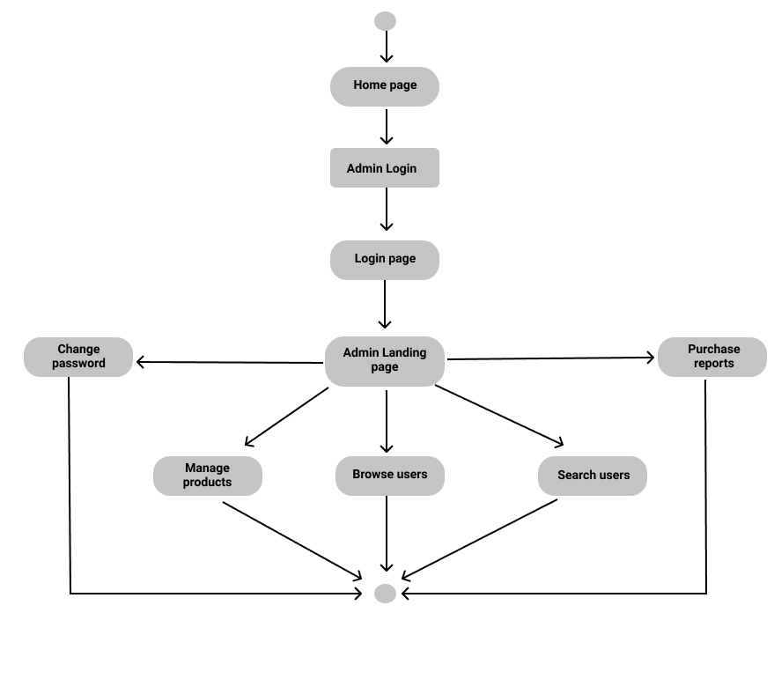

Database table design and relationship:

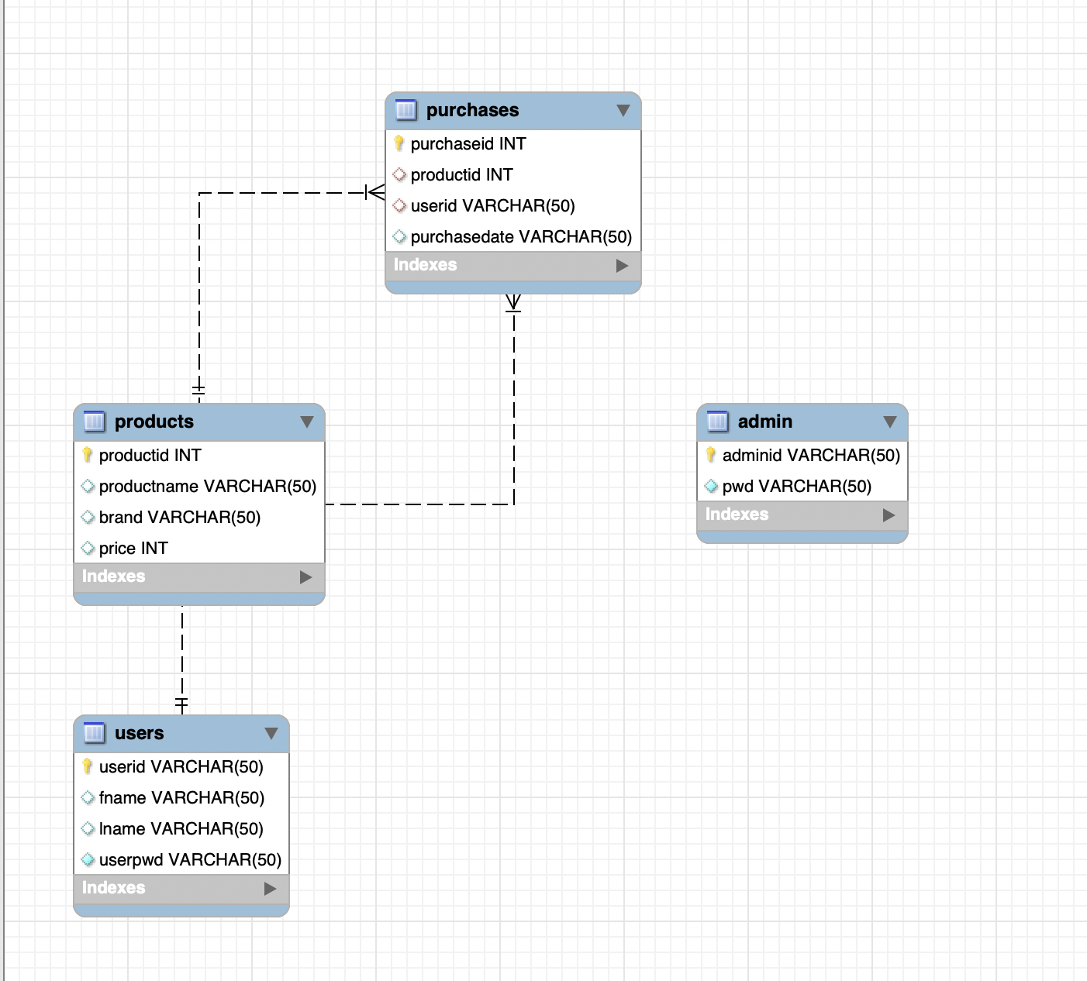

Folder Structure:

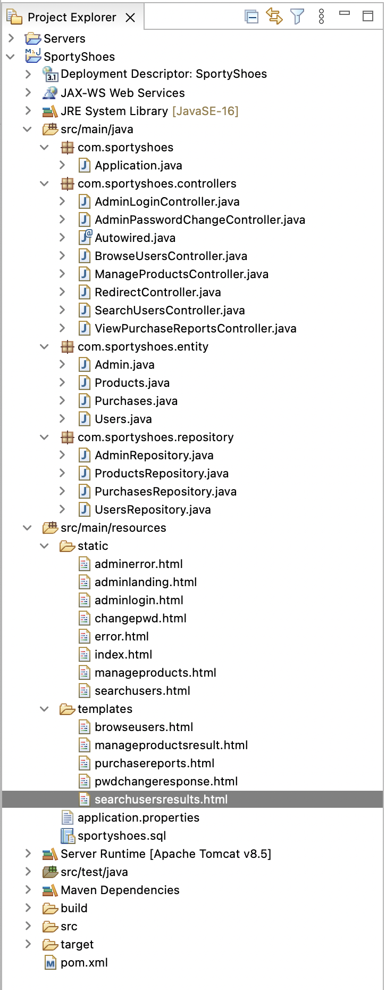

Project code:

pom.xml

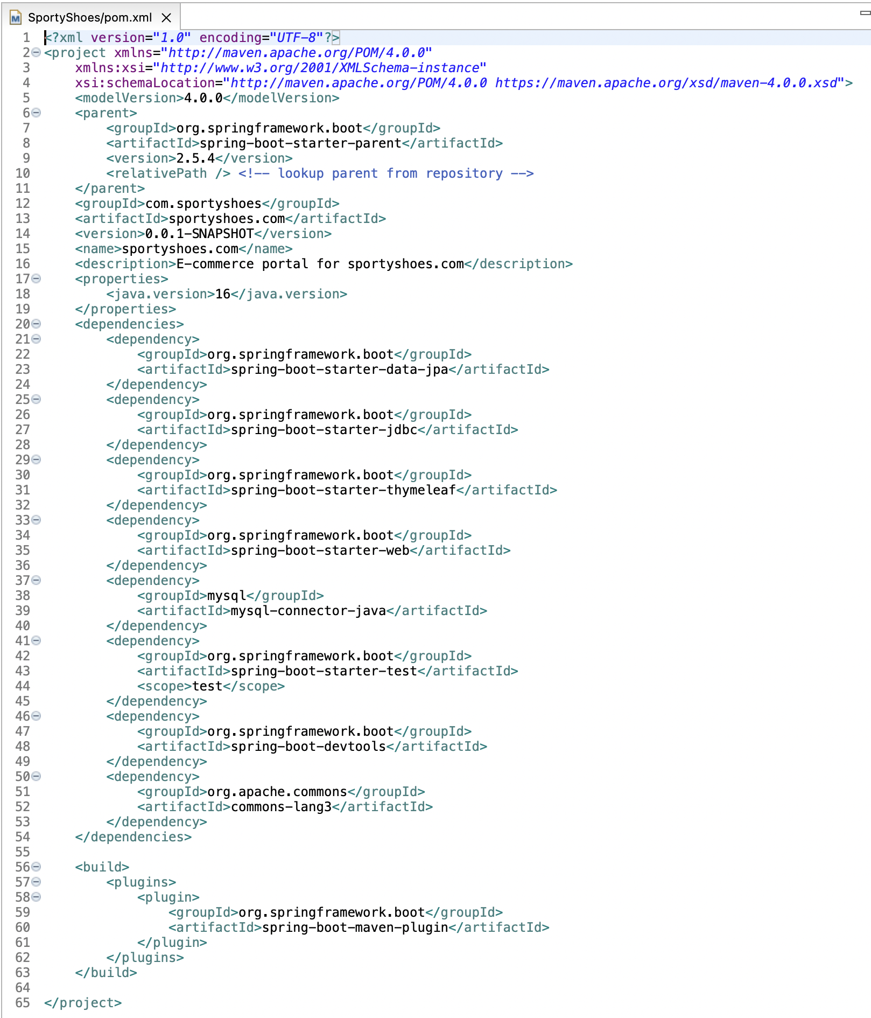

**package** com.sportyshoes;

Application.java

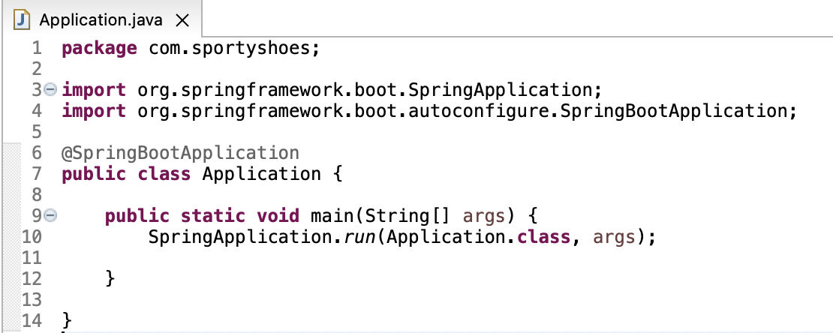

**package** com.sportyshoes.controllers;

AdminLoginController.java:

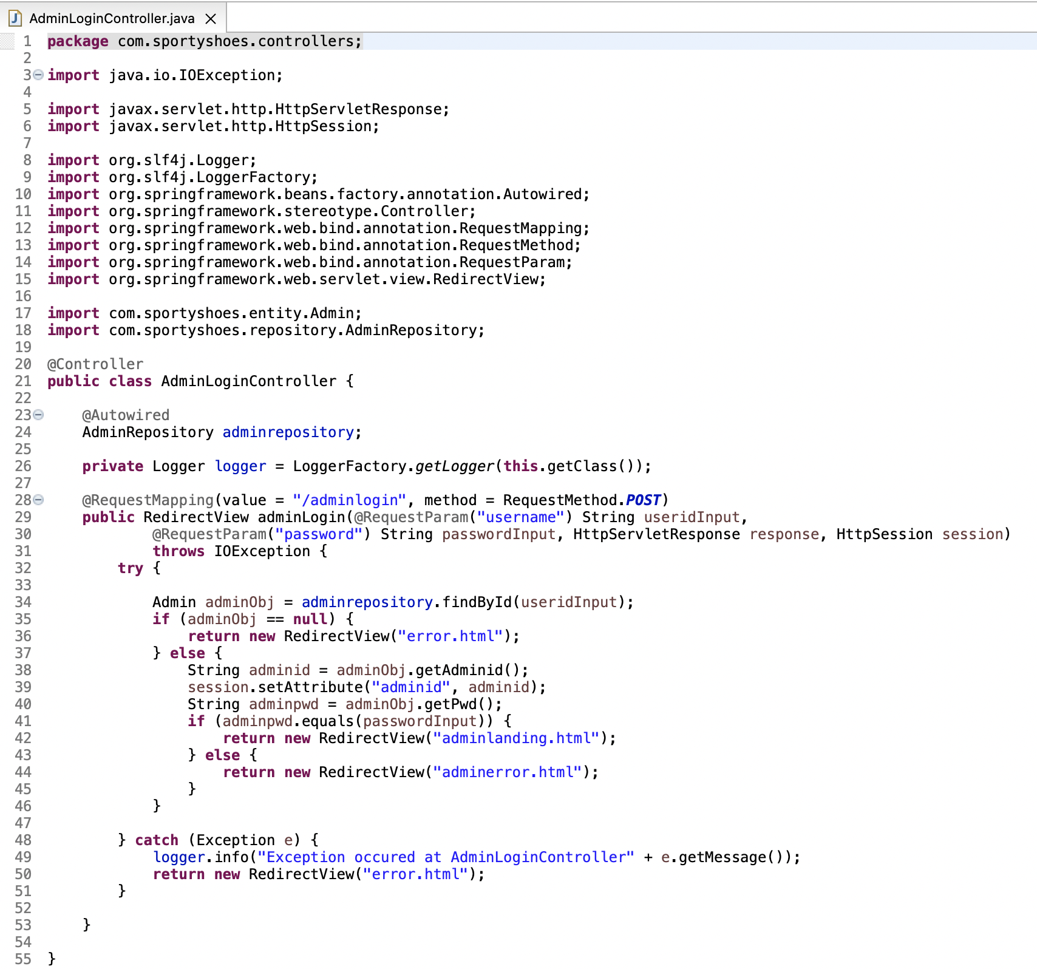

AdminPasswordChangeController.java

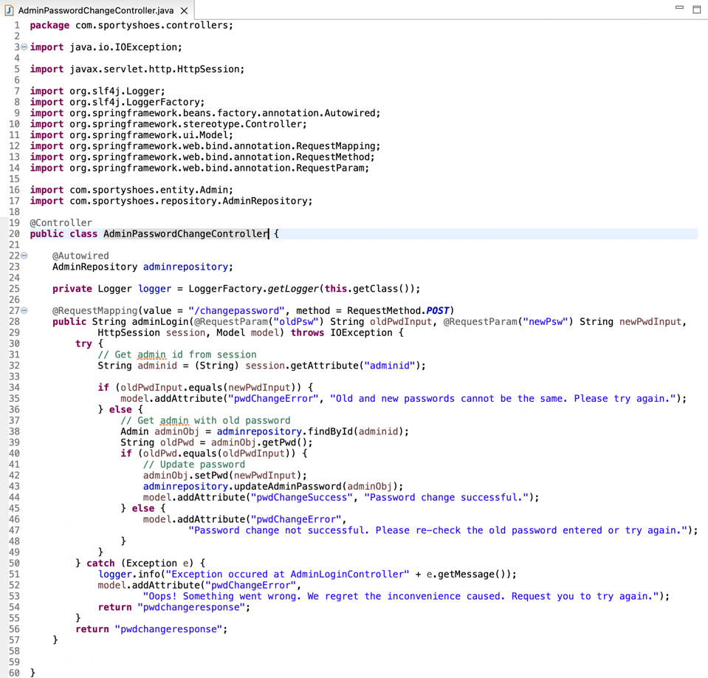

AdminPasswordChangeController.java:

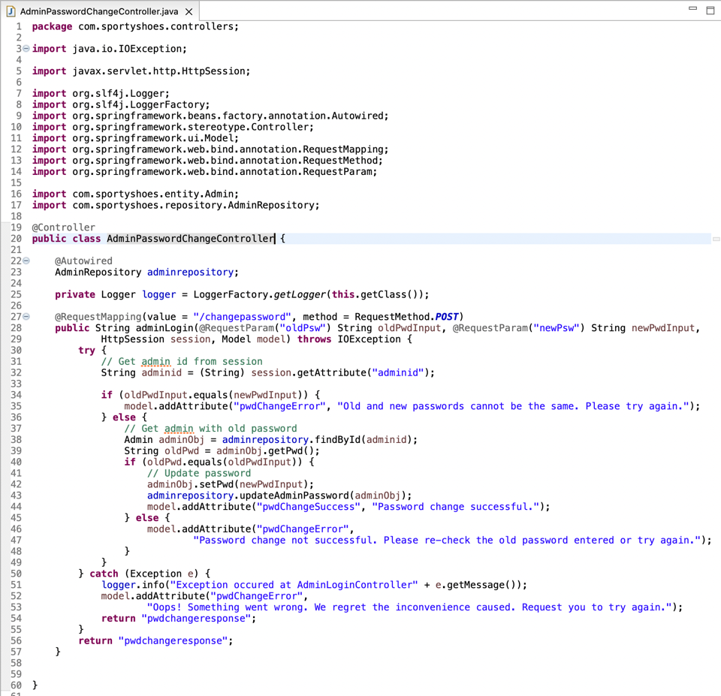

## BrowseUsersController.java:

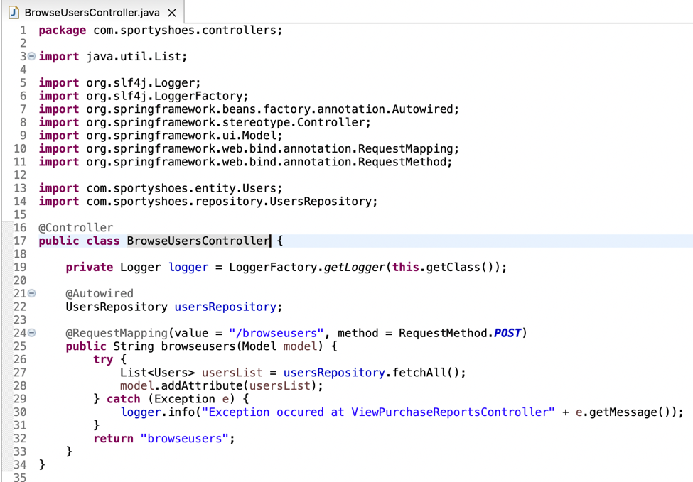ManageProductsController.java:

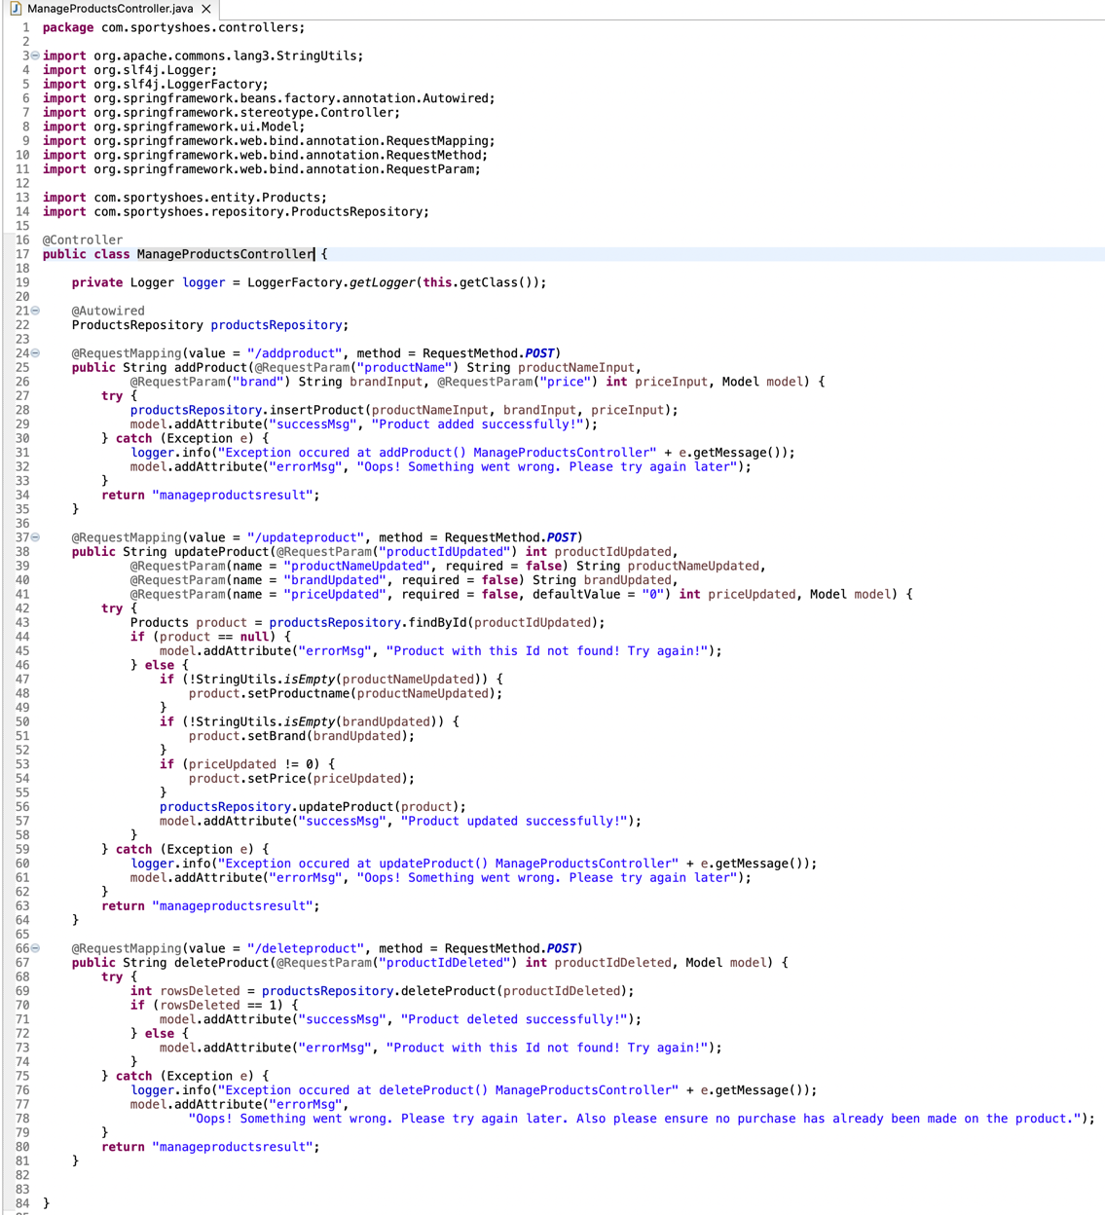

RedirectController.java:

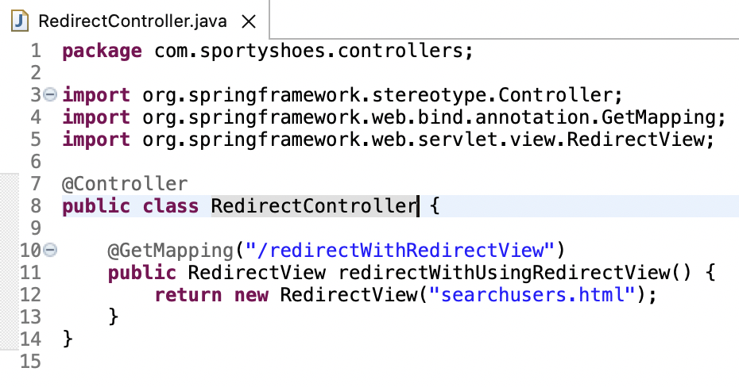

SearchUsersController.java:

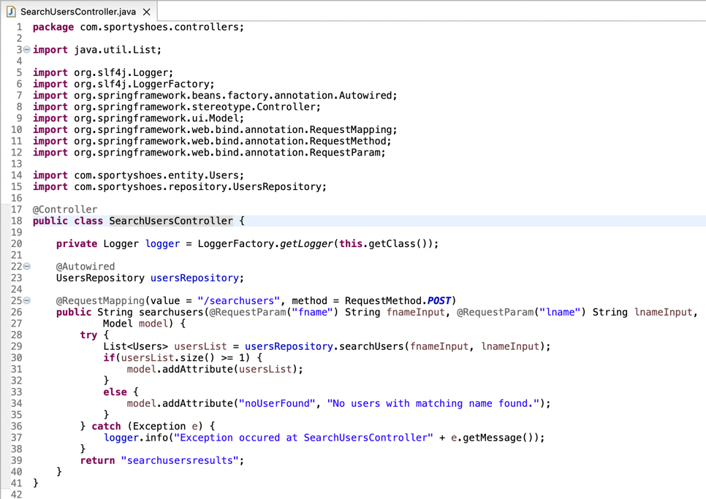

ViewPurchaseReportsController.java:

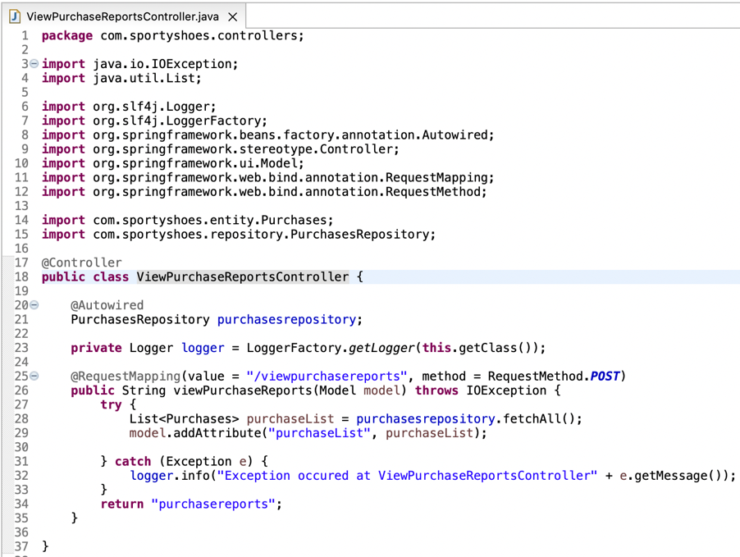

**package** com.sportyshoes.entity;

Admin.java:

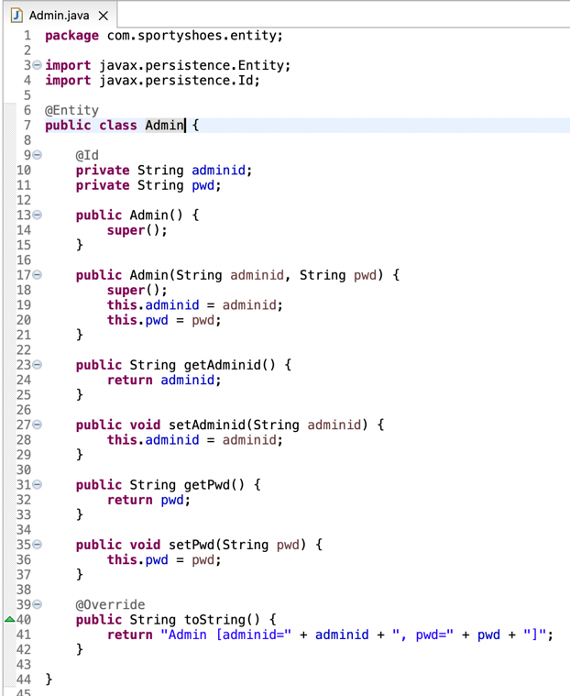

Products.java:

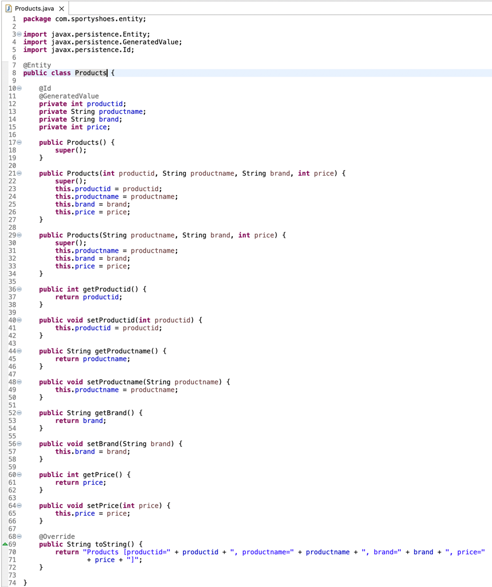

Purchases.java:

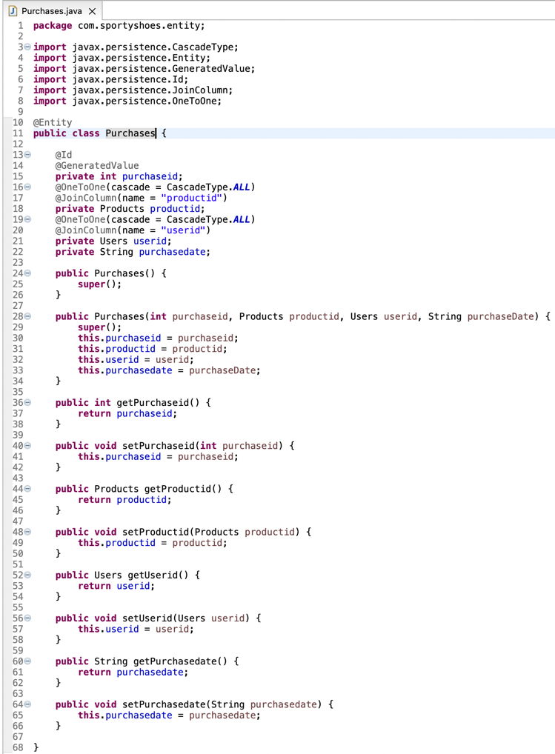

Users.java:

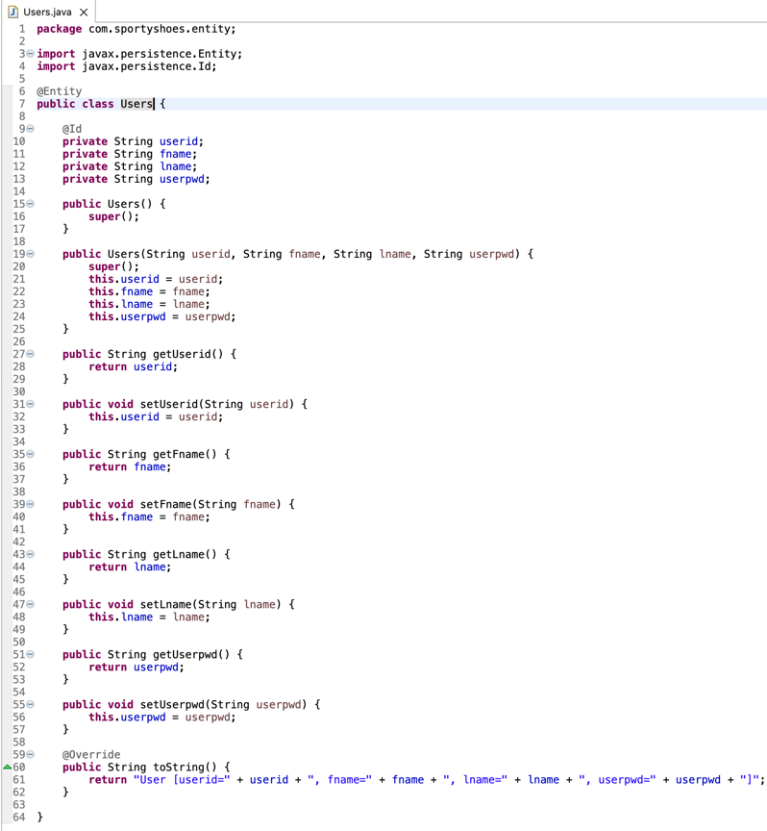

**package com.sportyshoes.repository;**

AdminRepository.java:

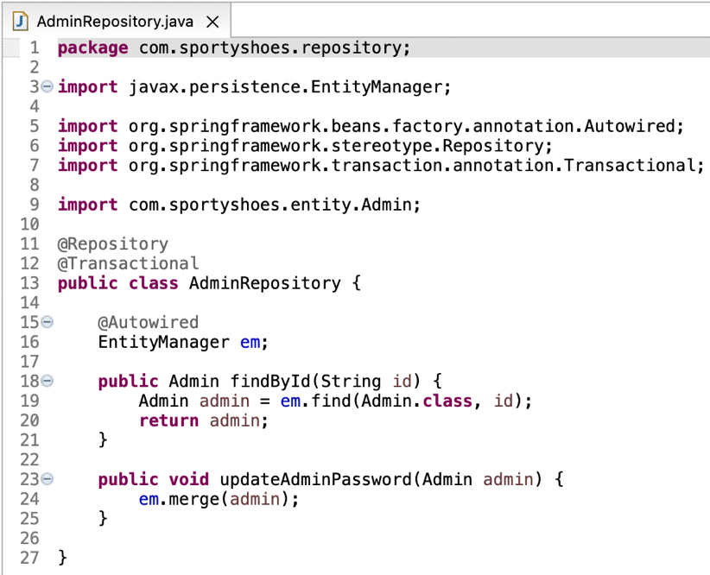

## ProductsRepository.java:

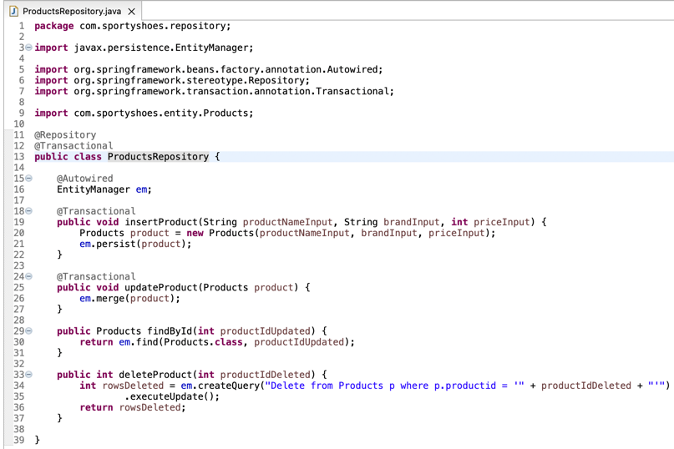

## PurchasesRepository.java:

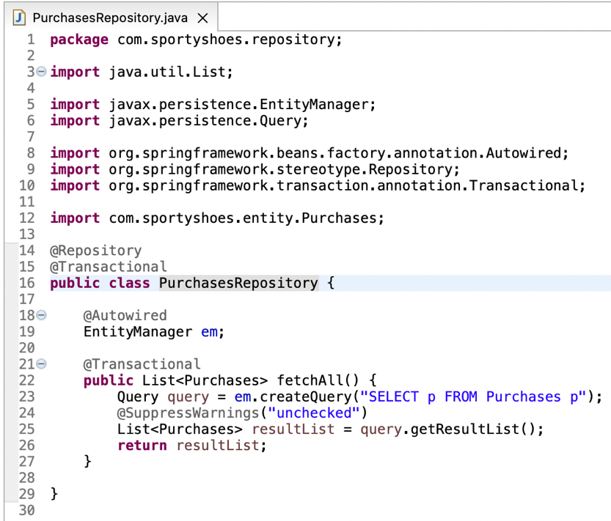

## UsersRepository.java:

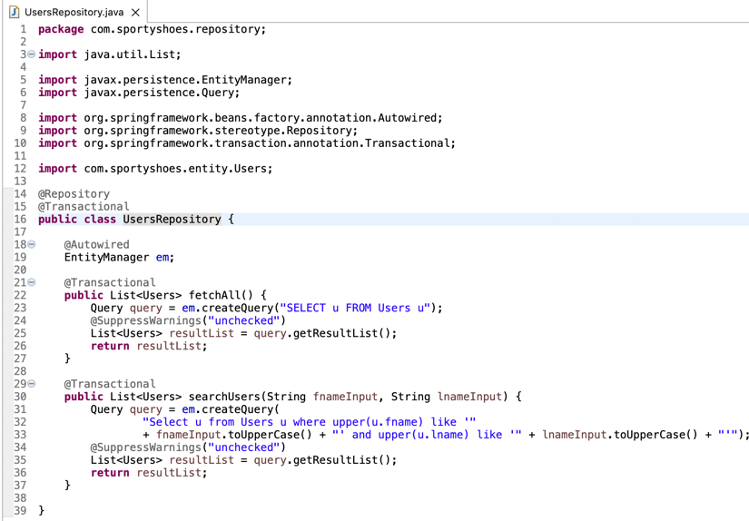

sportyshoes.sql

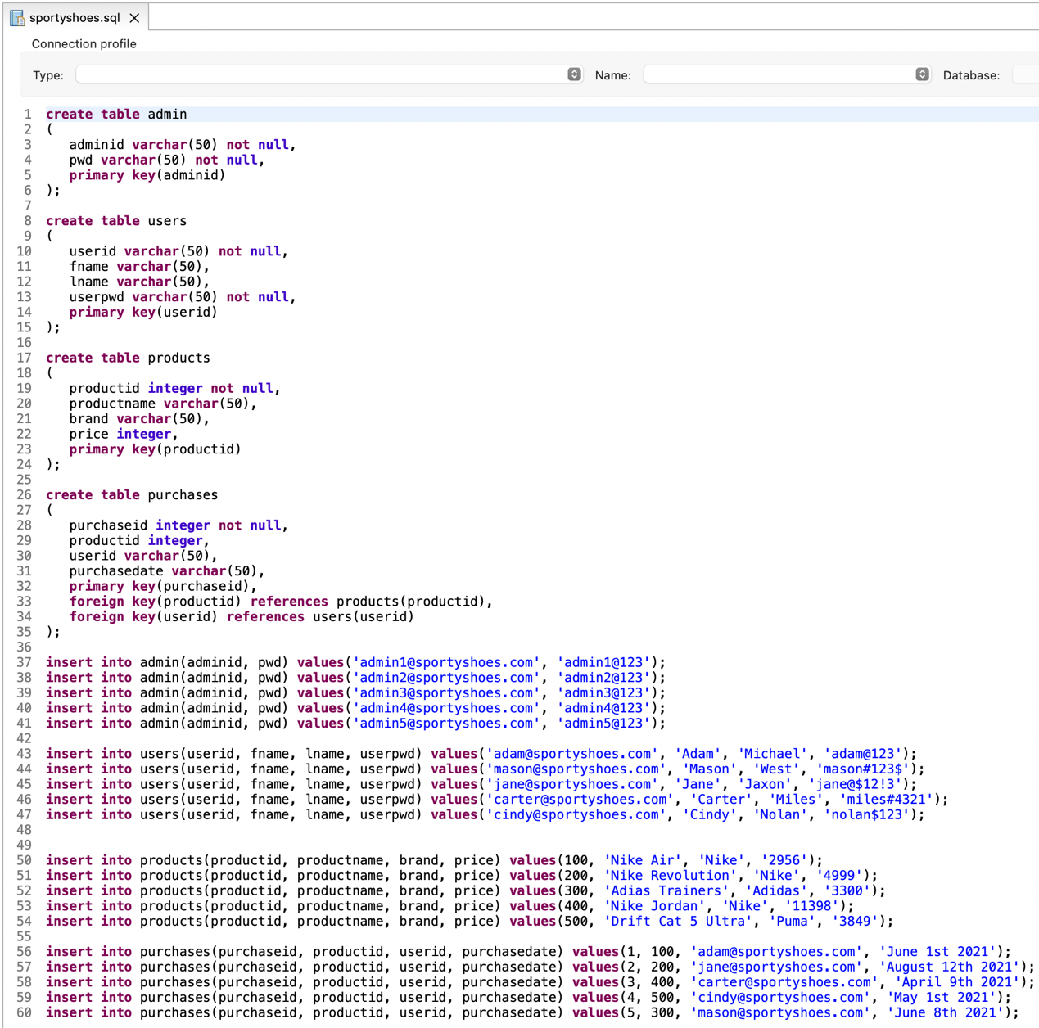

Pushing the code to GitHub repository